[https://docs.spring.io/spring/docs/5.1.10.BUILD-SNAPSHOT/spring-framework-reference/web.html#mvc-servlet](https://docs.spring.io/spring/docs/5.1.10.BUILD-SNAPSHOT/spring-framework-reference/web.html" \l "mvc-servlet)

# DispatcherServlet

## ServletContext

## AbstractAnnotationConfigDispatcherServletInitializer

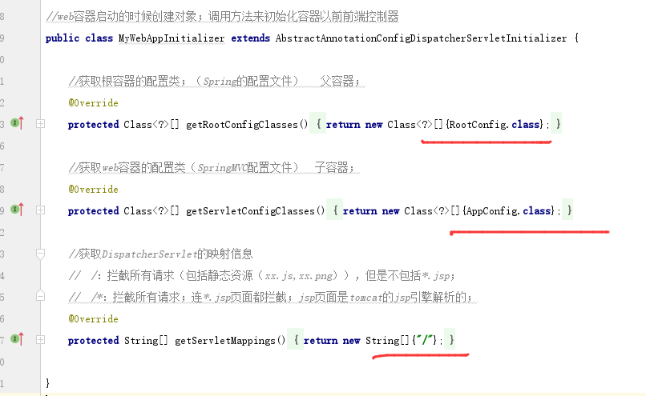

指定applation.xml 和 spring-mvc.xml

# 配置扫描包

